**TOOGLE.BID**

**Flow Implementation**

**06.02.2018**

**PURCHASER**:

1.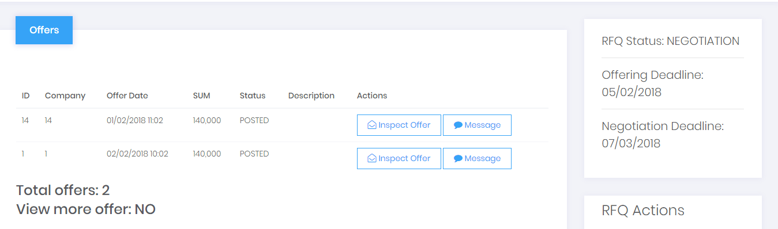 Insert the button REQUEST OFFER UPDATE

2. Once purchaser clicks on the button REQUEST OFFER UPDATE automatically appear a DATE FIELD and purchaser must insert the OFFER UPDATE DEADLINE

* 1. When purchaser click on the button REQUEST OFFER UPDATE, Suppliers which offers have been opened receive a message with the offer update request
  2. RFQ Status changes from NEGOTIATION to OFFER UPDATING

**SUPPLIER**

3. Supplier which offers have been opened during the NEGOTIATION PHASE receive a message with the UPDATE RFQ REQUEST by purchaser.

4. Supplier enter MY OFFERS and it sees on its list corresponding to RFQ status OFFER UPDATE the options MESSAGE; VIEW and UPDATE

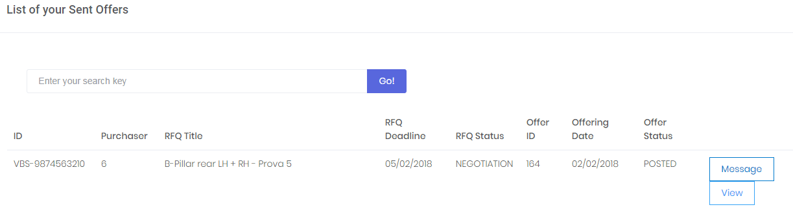

5. Clicking on UPDATE supplier must be allowed to change the COST BREAKDOWN fields within the UPDATE DEADLINE.

6. Once the offer is updated Supplier POST it.

After the OFFER UPDATE DEADLINE, the flow is the same as before, purchaser open the offer list and makes the DEAL with the best offer and reject the others.